**STARAGILE DOCKER ASSIGNMENT -1**

**1. Get the Address Book Application:**

* Clone the repository from GitHub using Git. 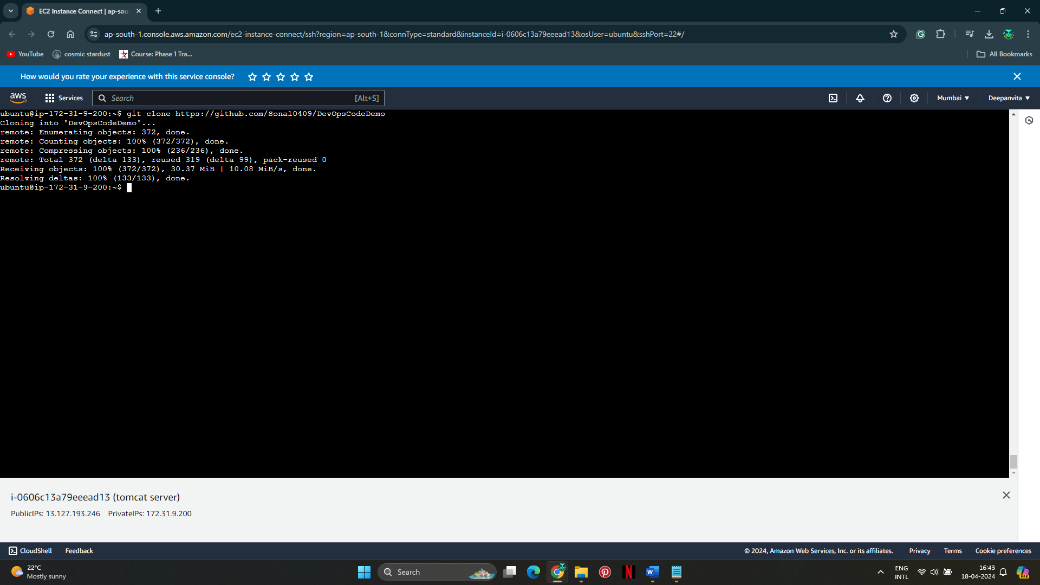

**2. Deploy on Tomcat Server:**

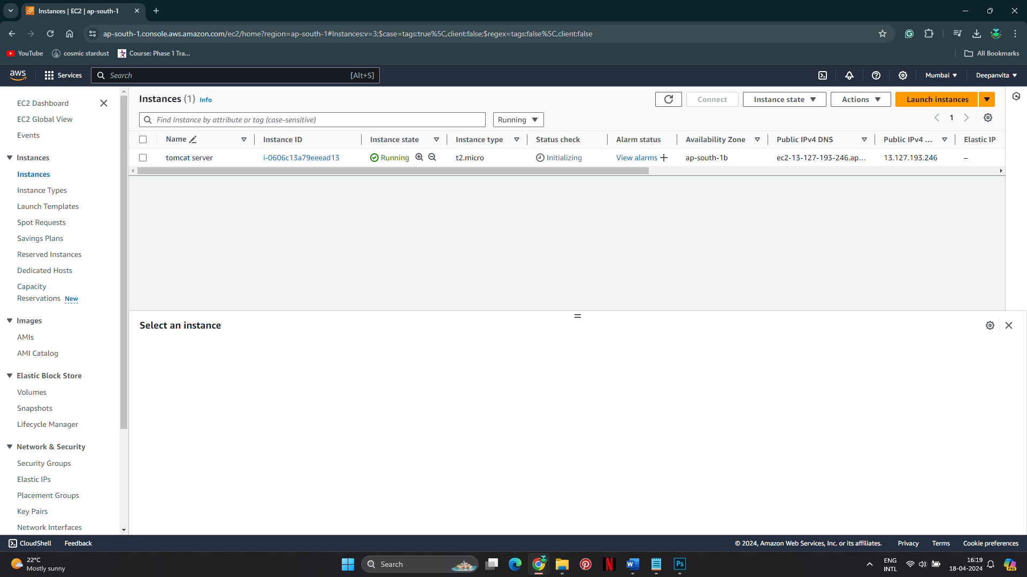

* Make sure you have Apache Maven installed on your system. 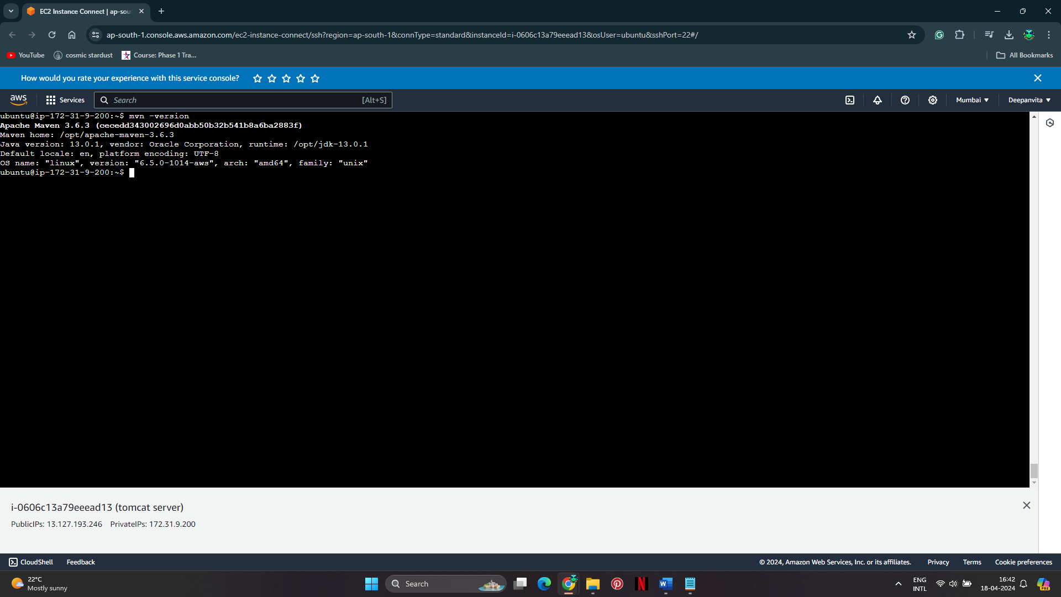
* Navigate to the project directory.

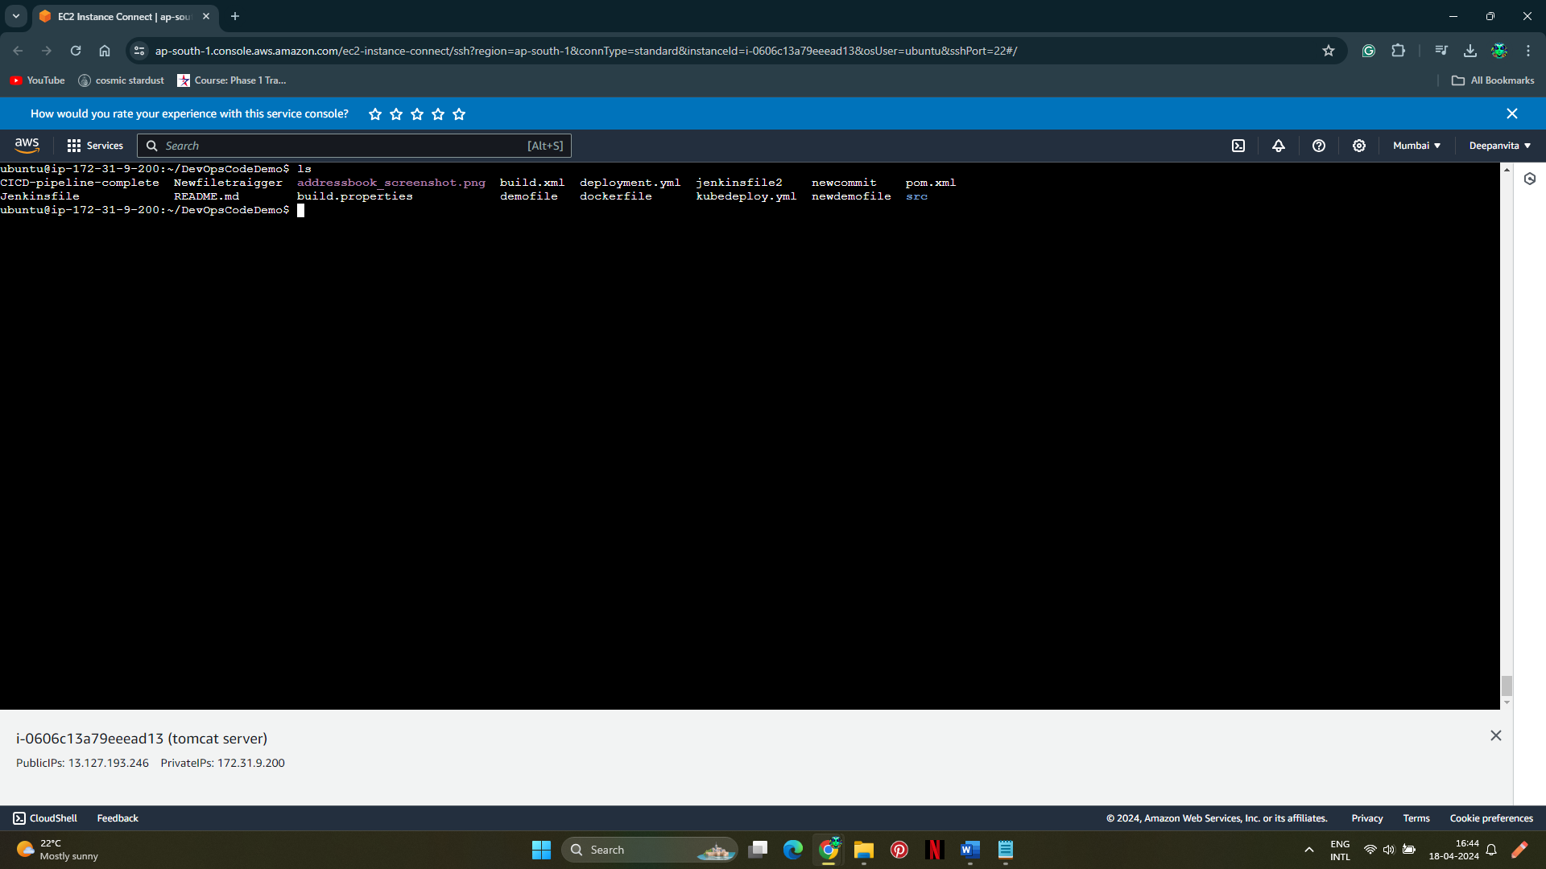

* Build the war file using Maven:

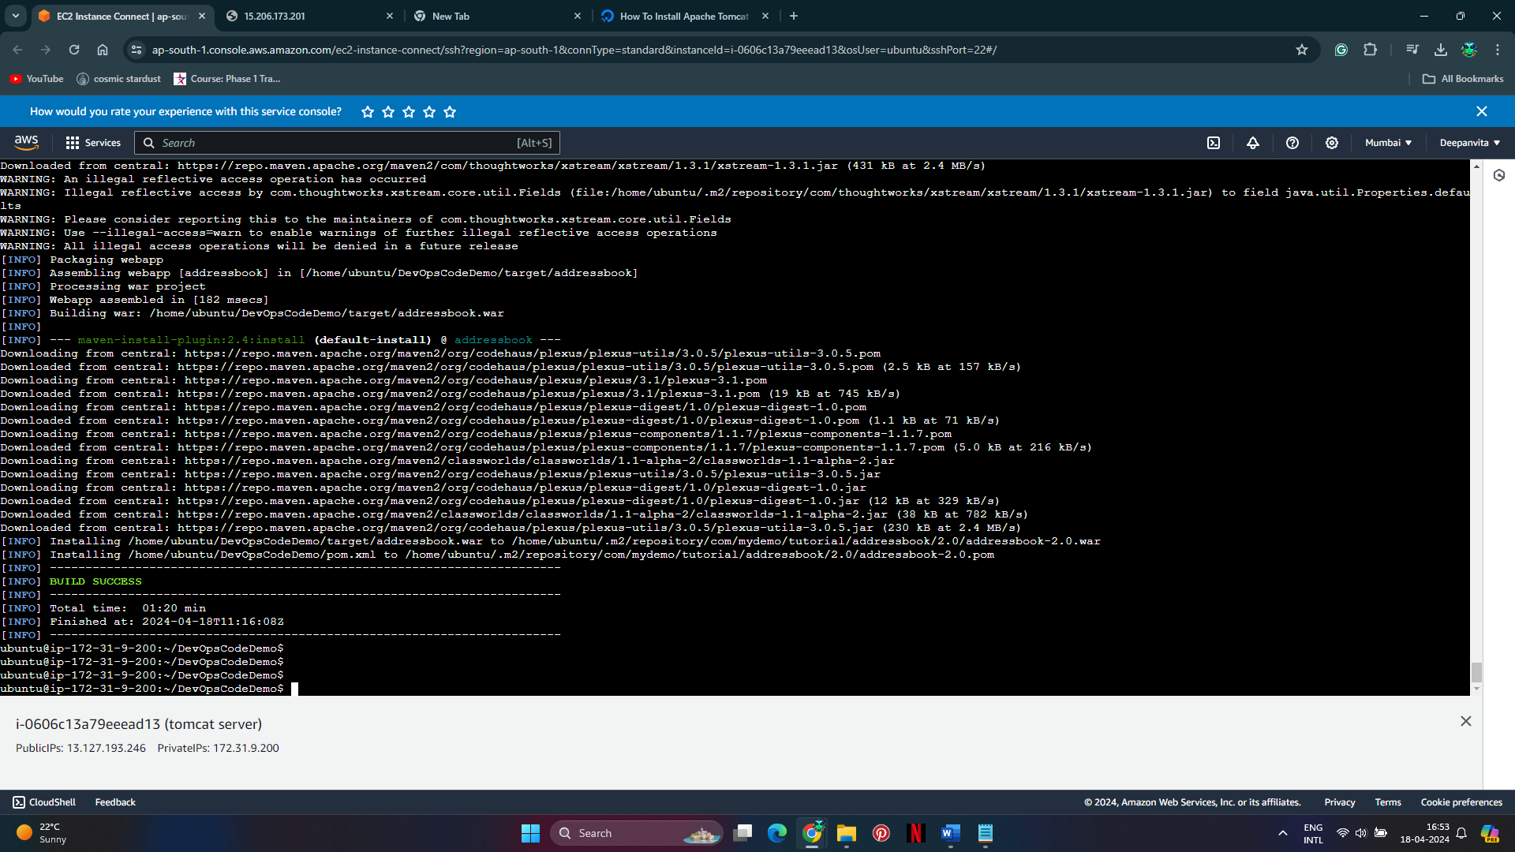

* It will generate the **addressbook.war** file in the **target** directory.
* Deploy the war file to Tomcat's webapps directory.

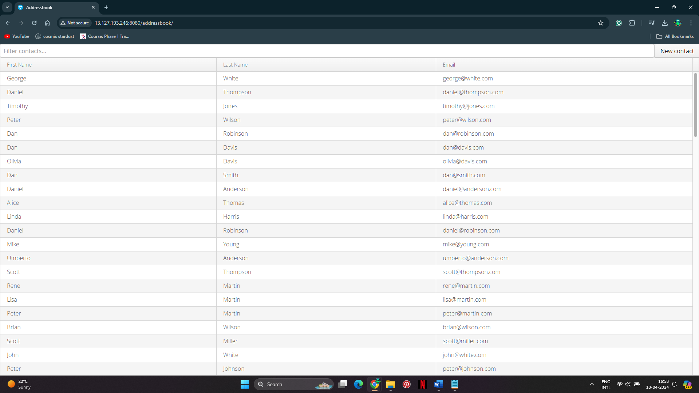

**3. Write a Dockerfile:**

* 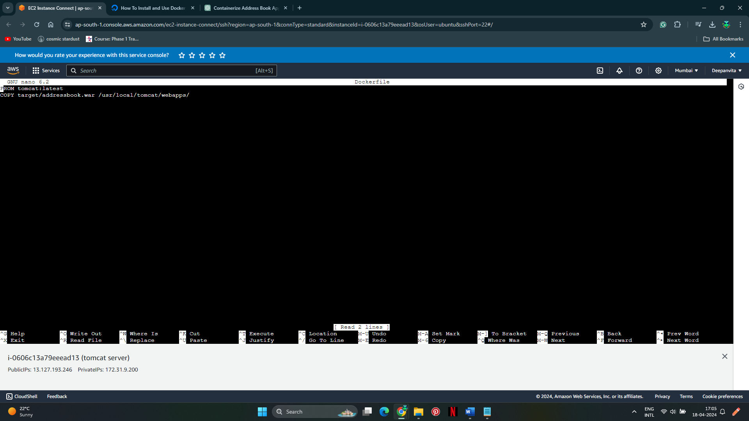

**4. Build Docker Image:**

build the Docker image:

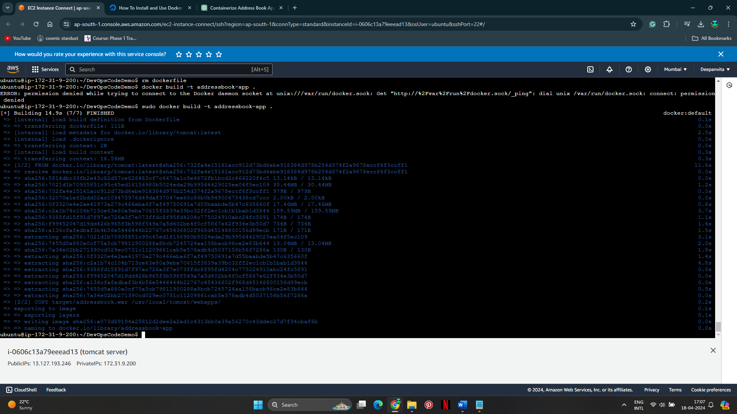

**5. Push to Docker Hub:**

* Log in to Docker Hub
* Enter Docker Hub username and password
* Tag Docker image with Docker Hub username and repository name:

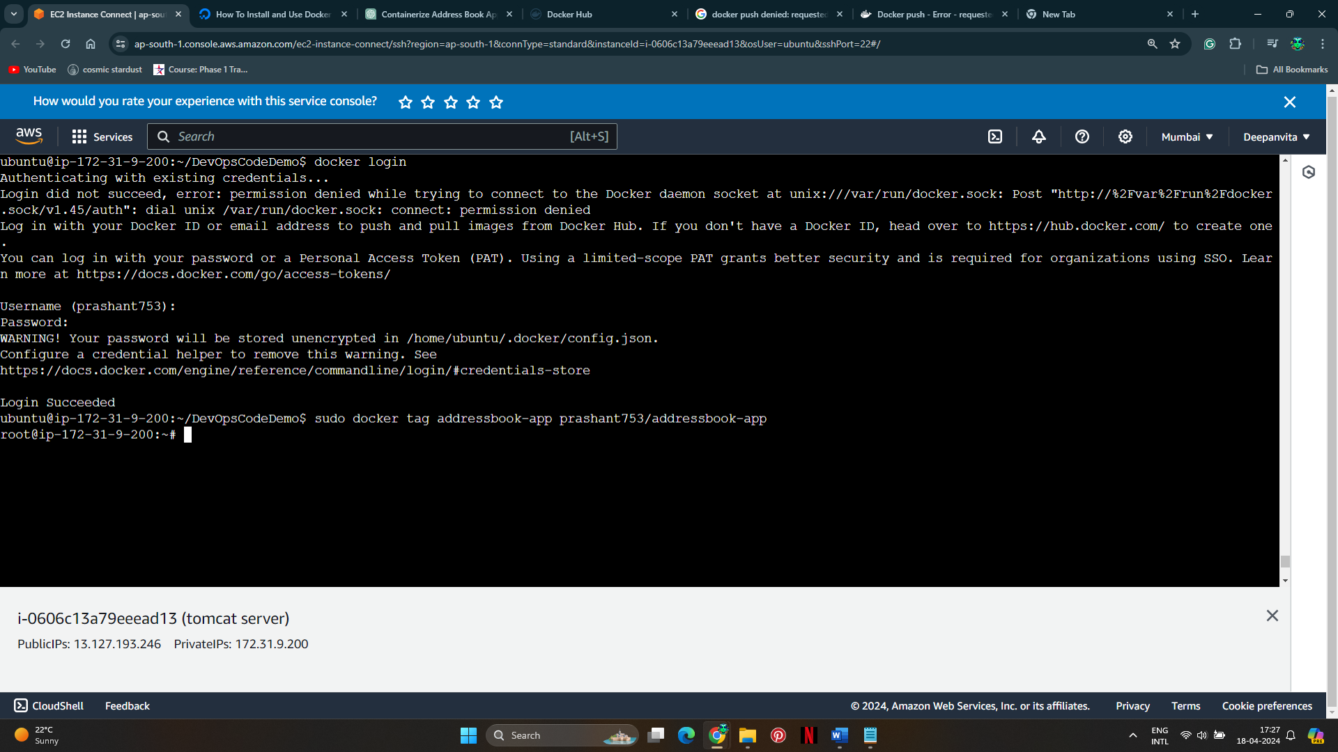

Push the image to Docker Hub:

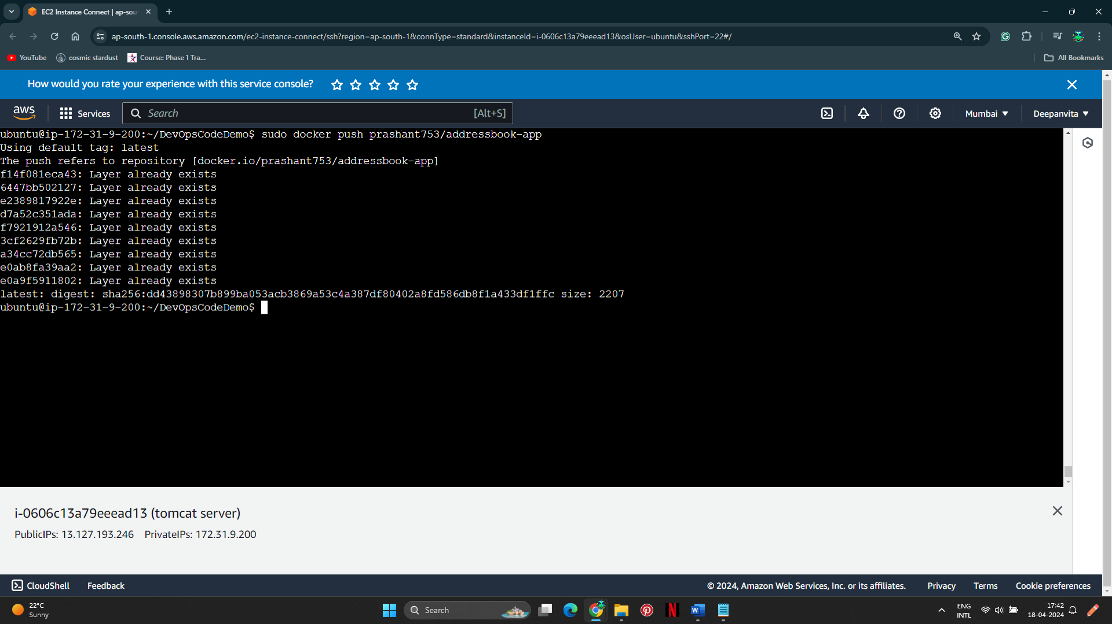

**6. Run Docker Image:**

* Pull the image from Docker

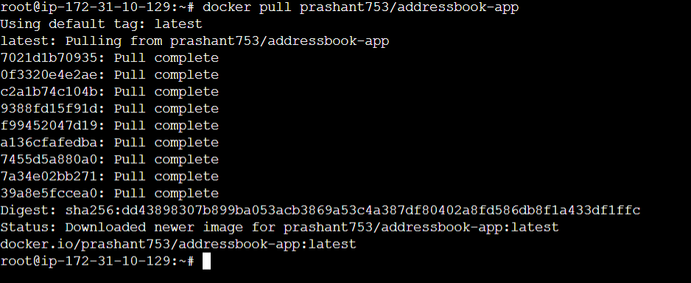

Run the container: 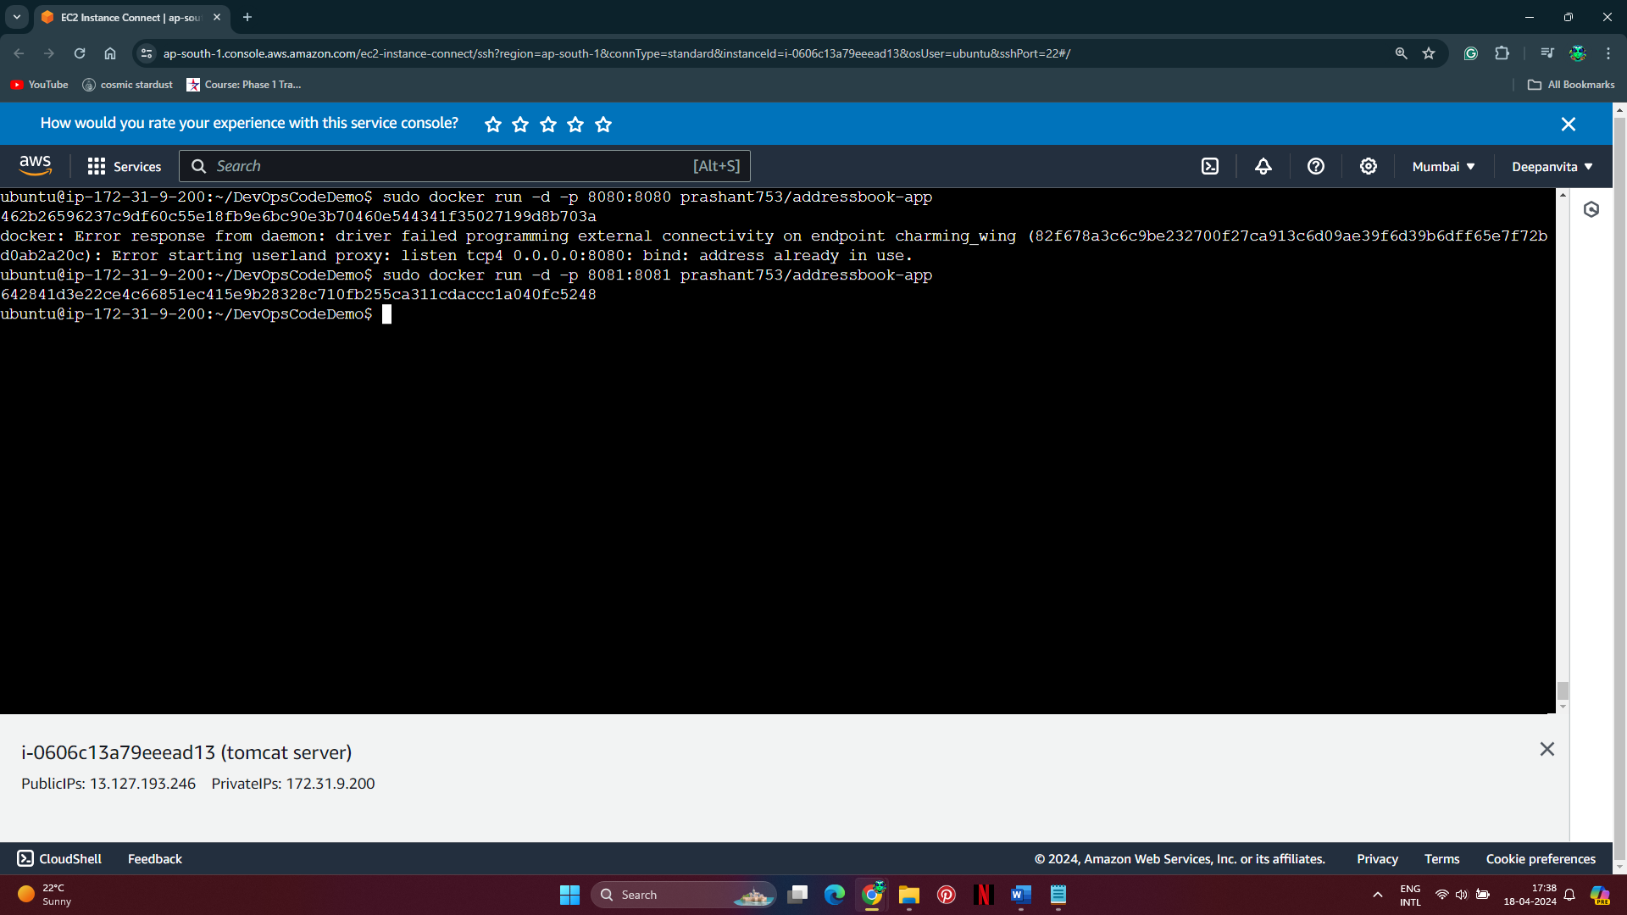

**7. Verify Application:**

